**TOPIC 1.1.D – REVISION MAT**

1. I can define the key terms used within the respiratory system.
2. I can identify the pathway of the air through the respiratory system.
3. I can explain the role of the diaphragm and intercostal muscles during inhalation & exhalation.
4. I can describe term gaseous exchange and how it occurs.

**KEY TERMS:**

BREATHING RATE:

TIDAL VOLUME:

MINUTE VENTILATION:

**GASEOUS EXCHANGE:**

[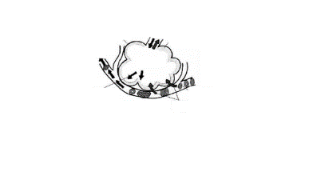](https://www.google.co.uk/url?sa=i&rct=j&q=&esrc=s&source=images&cd=&cad=rja&uact=8&ved=0ahUKEwj2gN3ixO_SAhUmLMAKHQrZAw8QjRwIBw&url=https://www.tes.com/teaching-resource/gas-exchange-in-the-alveoli-6149740&bvm=bv.150475504,bs.1,d.ZGg&psig=AFQjCNEwtZqu5jFkRqdztm_A1YAROpjY4w&ust=1490458504904671)

**RESPIRATORY**

**SYSTEM**

**LABEL THE LUNGS**

[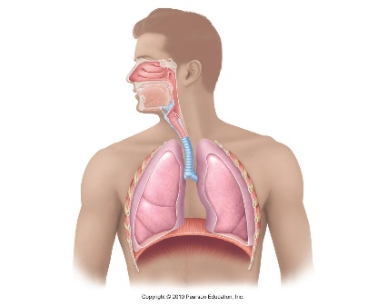](http://www.google.co.uk/url?sa=i&rct=j&q=&esrc=s&source=images&cd=&cad=rja&uact=8&ved=0ahUKEwjn58W4w-_SAhVBIMAKHbG4BGgQjRwIBw&url=http://www.livebinders.com/play/play?id%3D1643003&psig=AFQjCNF-XL8E3v3L5qpPDxbX_Er9jtWScw&ust=1490458142288191)

**Pathway of air**

**M_ _ _ _ ;**

**N_ _ _ ;**

**T _ _ _ _ _ _ ;**

**INHALATION – describe what happens to the**

**Diaphragm and intercostal muscles:**

**B _ _ _ _ _ _ ;**

**EXHALATION – describe what happens to the diaphragm and intercostal muscles:**

[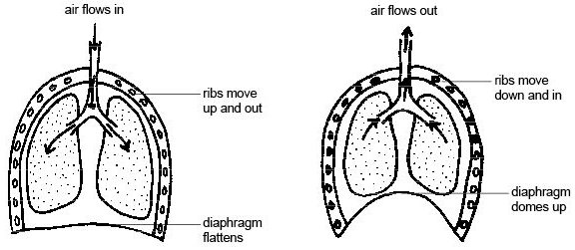](https://www.google.co.uk/url?sa=i&rct=j&q=&esrc=s&source=images&cd=&cad=rja&uact=8&ved=0ahUKEwjJ3ZLdw-_SAhXrKcAKHZhuC7AQjRwIBw&url=https://en.wikibooks.org/wiki/Anatomy_and_Physiology_of_Animals/Respiratory_System&bvm=bv.150475504,bs.1,d.ZGg&psig=AFQjCNHQAMxDb7PS2-FZPjRUF5tou4H0yw&ust=1490458215173972)

**B _ _ _ _ _ _ _ _ _ ;**

**A _ _ _ _ _ _ ;**