[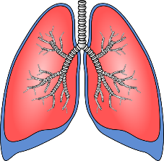](https://www.google.co.uk/url?sa=i&rct=j&q=&esrc=s&source=images&cd=&cad=rja&uact=8&ved=0ahUKEwiFn4j6wdPUAhXHlxoKHVOUAyEQjRwIBw&url=https://www.clker.com/clipart-lungs-1.html&psig=AFQjCNErfGvPiAfaY2XMuVfdrWISPdXvbg&ust=1498291765622413)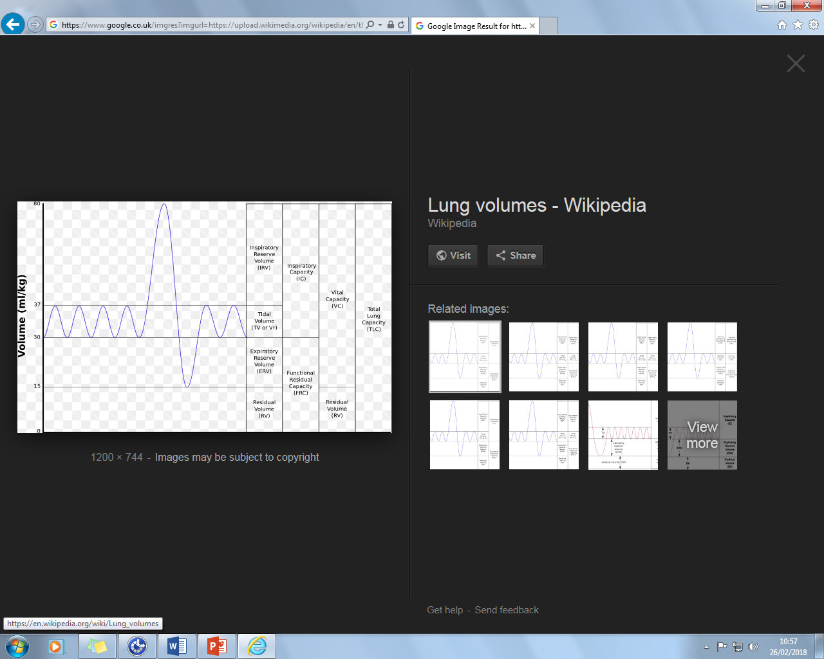

Identify

**Label diagram:**

**Structure & Function of the Respiratory System**

[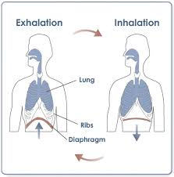](http://www.google.co.uk/url?sa=i&rct=j&q=&esrc=s&source=images&cd=&cad=rja&uact=8&ved=0ahUKEwiW9dvowtPUAhWB6xQKHcezCqMQjRwIBw&url=http://aventalearning.com/content168staging/2007BiologyB/unit9/section9_3.html&psig=AFQjCNE2t2BVreFWOhgBM8dOIROThcjynA&ust=1498291980808146)

**DEFINITIONS:**

1. **Breathing Rate:**
2. **Tidal Volume:**
3. **Minute Ventilation:**

**Explain:**

**1.1.d Respiratory System**

**AEROBIC & ANAEROBIC RESPIRATION:**

[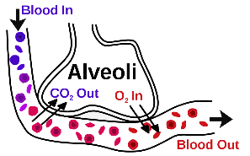](http://www.google.co.uk/url?sa=i&rct=j&q=&esrc=s&source=images&cd=&cad=rja&uact=8&ved=0ahUKEwi71YK9wtPUAhXFshQKHc6-CHsQjRwIBw&url=http://biology4alevel.blogspot.com/2015/03/52-summary-of-gas-exchange.html&psig=AFQjCNHsZH7VO1crau7nKTLIaw3TVNjkhw&ust=1498291913264741)

**Explain gaseous exchange:**

* AEROBIC:

(Explain + sporting example)

* ANAEROBIC:

(Explain + sporting example)