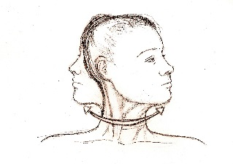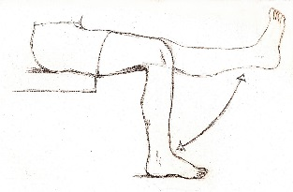

**TYPES OF MOVEMENT AT A JOINT**

**SYNOVIAL JOINTS**

What is a synovial joint?

**JOINT TYPE 1 =**

(State which two areas you find this type of joint + the articulating bones)

**JOINT TYPE 2 =**

(State which two areas you find this type of

joint + the articulating bones)

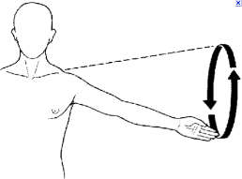

**LOCATION OF BONES**

**19 BONES IN TOTAL**

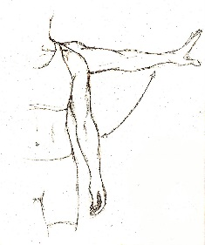

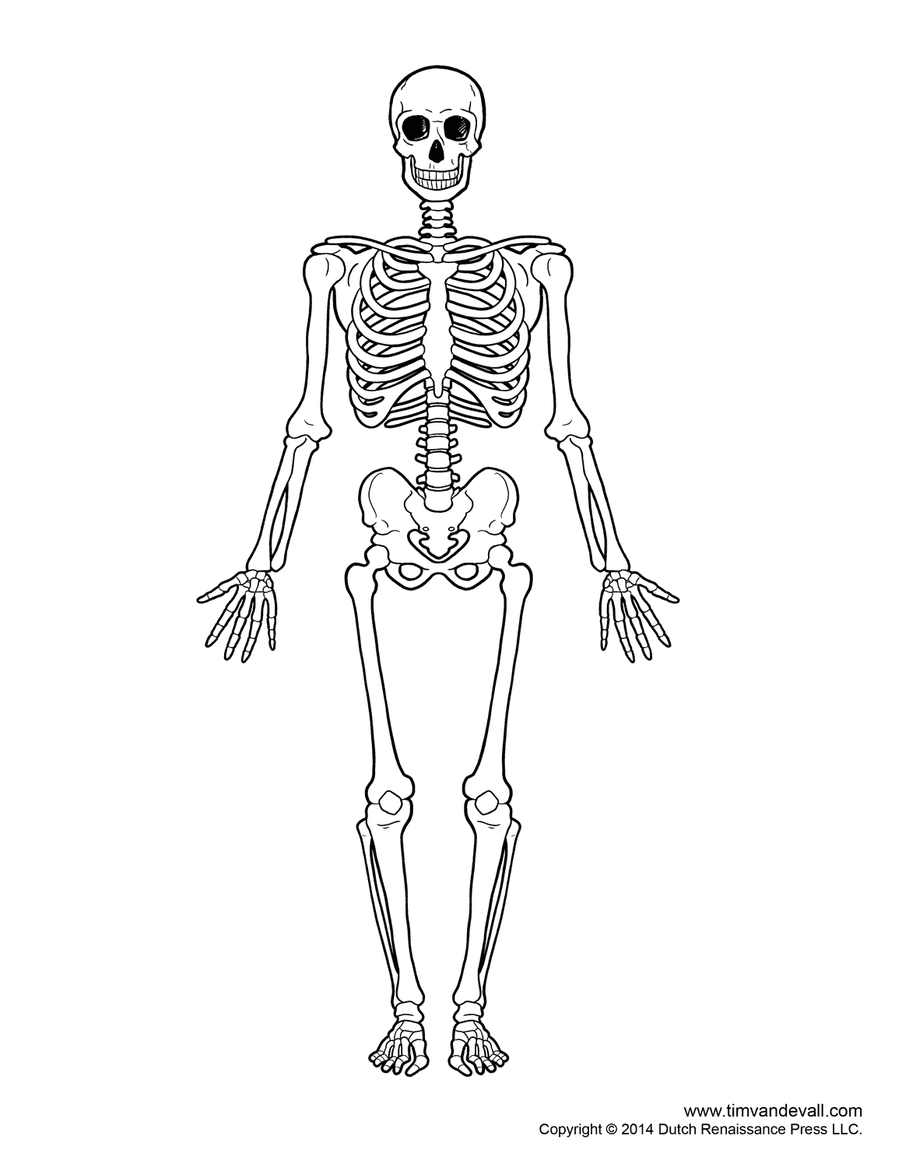

**1.1.a Skeletal System**

**COMPONENTS OF A JONT:**

**3 IN TOTAL**

**FUNCTIONS OF THE SKELETON:**

**6 FUNCTIONS IN TOTAL**



* LIGAMENT:
* CARTILAGE:
* TENDONS: